Personal Details  ails |  |  | 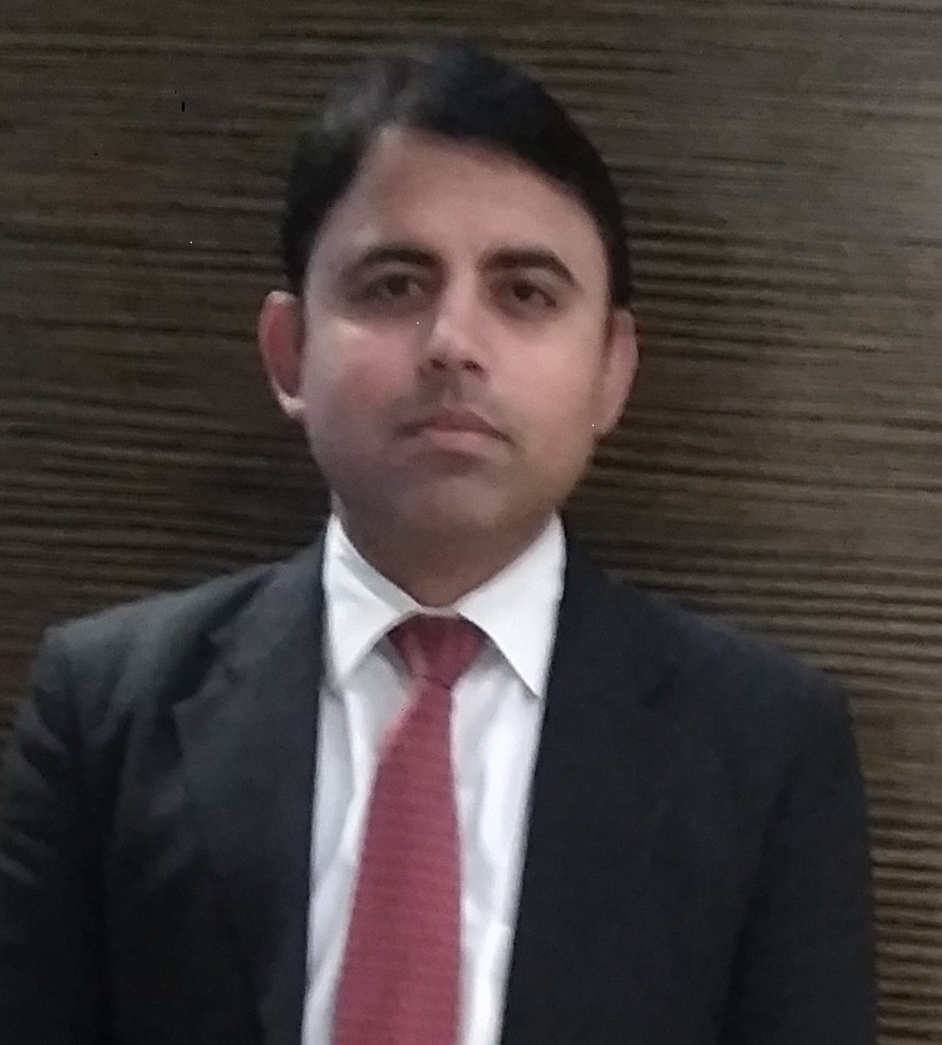
Name | Bishnu Kumar Mishra
Date of Birth | 28th Jan. 1985
Fathers Name | Mr. Arvind Mishra
Nationality | Indian
Marital Status | Married
Sex | Male
Passport | Ready
OBJECTIVE

To work with an organization that enables me to utilize my skills, to achieve the organizational goals and polish myself further.

HOME ADDRESS
Village | Gadhiya
Post | Gadhiya
District | Saharsa
State | Bihar | Mobile | + 91 7895880187
Zip (Postal Code) | 852201
E Mail | bishnumishra255@gmail.com

EDUCATIONAL BACKGROUND & QUALIFICATION

QUALIFICATION | College /School Name | Board | Remark
3rd Year BSc. In Hospitality | IHM, Goa | NCHMCT, New Delhi | First Class
2nd Year BSc. In Hospitality | IHM, Goa | NCHMCT,New Delhi | First Class
1st Year BSc. In Hospitality | IHM, Goa | NCHMCT,New Delhi | First Class
S.C.C | Ram Mohan Roy, Seminary Patna (Bihar) | Bihar Intermediate Educational Council | First Class
H.S.C | Mithila Public School Bhadreshwar Araria (Bihar) | C.B.S.E , New Delhi | First Class

CAREER ACHIEVEMENTS & AWARDS

- Selected as a Certified Departmental trainer in Four Points by Sheraton Dehradun.
- Won SPG (Starwood Hotels) Mile stone contest in Year 2016.
- Awarded Employee of the month & many more appreciation letter.
- Awarded appreciation letter by college management team.
- Received Guest excellent service feedback on Trip advisor & SPG guest experience index.

Work History

Lobby Manager

Currently Working with Jaypee Residency Manor, Mussoorie (Uttarakhand) a five star deluxe hotel (A unit of Jaypee group of Hotels) as a Lobby manager from May 2019.

Duty Manager.
Company Name: - Hans Hotel, Connaught Place, New Delhi.
Employed: - Nov 2018 to April 2019.


Senior Duty Manager

Company Name:- Marriott international

Employed: - Feb 2014 to Nov 2018.

Employment Duration: - 4 years 08 Month.

Location:-Dehradun (India)
Worked with Four Points by Sheraton Dehradun as a Senior Duty Manager.
• Assures that all financial and credit procedures are followed. Follows up on credit problems with Front Office Manager and/or Credit Manager. Reviews all paid-outs, rebates, Petty Cash disbursements and Direct Billings. Checks cashiers’ work at end of shift to ensure all transactions are reconciled with proper approvals and endorsements.
• Assigning and overlooking the Duty Roster for the Front Office Department.
• Approve the working schedule for the team attendants and submits them to front office manager.
• Visits various IHM institutes for the process of recruitments and Viva’s.
• Approve and sign for allowances, rebates etc., as required by Front Office Cashier.
• Co-ordinate with all departments concerned in order to maintain Front Office functions properly.
• Continually review the operational arrangements and controls to maximize the efficiency levels and targets.
• Ensures that all associates report to duty punctually and maintain a high standard of personal appearance and Hygiene all the times.
• Approves leave requests for the Duty Managers after considering peaks and troughs in the business patterns. Maintains updated staff files on annual leave, medical leave, punctuality and personal details of the staff.

Duty Manager

Company Name:-Svelte Hotel & Personal suites, Saket , New Delhi (India).

Dates Employed:-Oct 2013 – Feb 2014.
Duty manager with Svelte Hotel & Personal suite •
To supervise the operation of the hotel through qualified, well-trained staff while maintaining high degree of guest satisfaction.
• Supervising the operations in the absence of Front Office Manager.
• To ensure smooth functioning of all sub departments of the property, thus ensuring guest delight.
• To monitor and review the monthly profit and loss statement, analyses results and take action when necessary.
• Responsible for National, International Conferences, Delegations, visits of Dignitaries, Launches and other major events.
• Formulate, conduct and oversee training programs / workshops for the staff.
• Participation in General / Senior Management meetings.
• GHA Enrollments & standards.
• Daily Up sell against targets (Rooms & Transport).
• Plan and Organize special events, Large group, incentive and festive promotions.
• Long stay billing and issues.
• Promotion of Brand Loyalty Scheme.
• Supervising, directing, coordinating, influencing and persuading staff in order to maintain high service standards of hotel.
• Helping room reservations and Guest relations to constantly improvise on their interactions with guest relating subjects and devising better methods to solve problems.

Front Office Executive

Company Name:-Svelte Hotel & Personal Suites, Saket , New Delhi.

Dates Employed Feb 2011 – Oct 2013.

Employment Duration: 2 years 9 Month.

Location: New Delhi, India.
Worked as Front Office executive.
• Ensuring proper maintenance of day to day reports & appropriate compilation of the same.
• Assessing team accomplishments motivate junior personnel and inculcating sense of team spirit.
• Be a one point contact for all hotel queries and complaints.
• Improving complaint handling techniques and ensure proper resolving of complaints.
• Focused on increasing the volume of business by up selling the room and by guiding the team towards the achievement of guest satisfaction to ensure repeat business.
• Ensuring proper formulation of reports for all departmental heads and timely distribution.



Guest Service Associate

Company Name:-Ginger Hotels (Taj Group) A Tata Enterprise.

Dates Employed:-Jul 2008 – Oct 2010.

Employment Duration: 2 years 4 months.

Location: New Delhi, India.
Worked with Ginger Taj Group of Hotel as Guest service associate.

Education:-

Institute of Hotel management & catering technology ,Goa, India.

Degree: Bachelor of Science in Hospitality & hotel administration.
Field of Study:-Hospitality & Hotel administration.
Grade:-1st class.
Dates attended:-2005 To 2008
Activities and Societies:- Participated in sports, cultural & social activities.
Blood donation, child education, city cleaning.

-----------------------------

Place: Bishnu Kumar Mishra

